# Lab 2: Advanced HTML

Goal: Practice Advanced HTML Tables and Forms.

1. Create a HTML5 file structure as the one shown below (the style is not important for now):

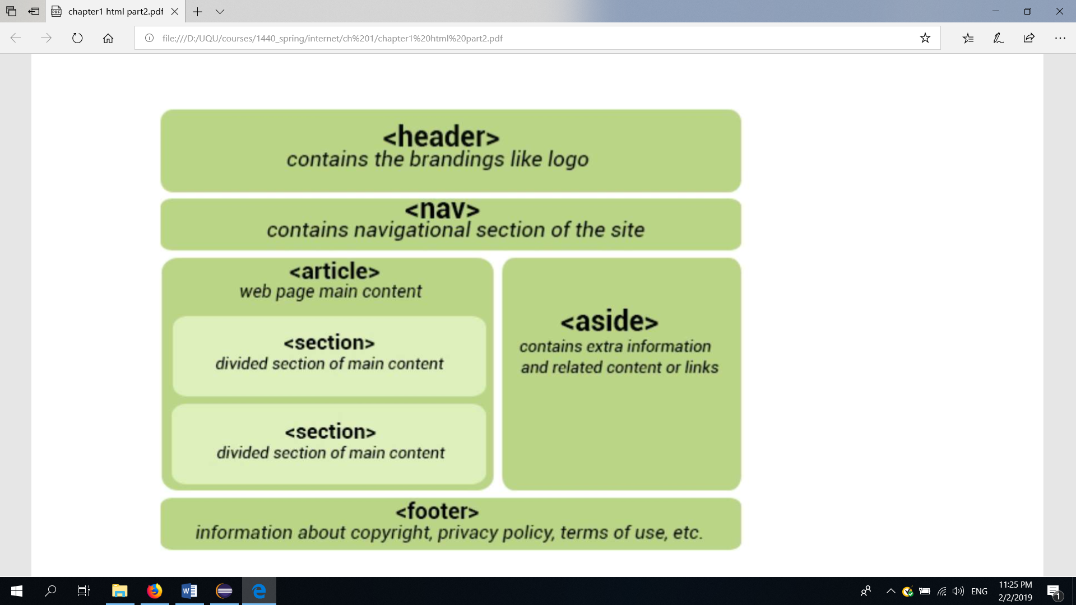

1. Create a form with HTML5 data validation:
   1. Every input element must be linked to its label using the **for** attribute.
   2. “region” can be one of the KSA regions (Mecca, Riyadh, Eastern Region, Asir, Jazan, Medina, Al-Qassim, Tabuk, Ha’il, Najran, Al-Jawf, Al-Bahah, Northern Borders Region).
   3. All fields are required except “website or domain name” and “project description”.
   4. Phone number must contain only numbers. It must contain at least 10 digits, at most 14 digits. You can use HTML pattern attribute:

 <input type="text" … pattern="[0-9]{10, 14}"… >

* 1. Use the title attribute of the input element to display a tooltip message informing the user about the expected input when he hovers over the input element:

.. title="10 to 14 digits"

* 1. Zip code must only contain digits and be no longer than 6 digits.
  2. Last name and first name can only contain alphabetical characters, no more than 20 each.

* 1. Include this CSS code in the head section of your html document to test the effect of data validation:

<style>

input:valid {

background-color: palegreen;

}

input:invalid {

background-color: lightpink;

}

</style>

1. Create an HTML table that displays your weekly schedule:

|  |  |  |  |  |  |
| --- | --- | --- | --- | --- | --- |
|  | Sunday | Monday | Tuesday | Wednesday | Thursday |
| 8:00 – 9:00 |  |  |  |  |  |
| 9:00 – 10:00 | Course A |  | Course B |  |  |
| 10:00 – 11:00 |  |  | Course A |  |  |
| 11:00 – 12:00 |  |  |  |  |  |
| 13:00 – 14:00 | Course C |  | Course C | Course B |  |
| 14:00 – 15:00 |  |  |  |  |  |
| 15:00 – 16:00 |  |  |  |  |  |

END.